**Phase 3: Data Modeling & Relationships**

**Objective:**

The goal of this phase was to build the custom data structure required to hold the bank's service data. This involved customizing standard Salesforce objects and creating new custom objects to meet the specific use cases identified in the project requirements.

**Completed Actions:**

* The standard Case object was customized to capture details specific to banking issues.
* The following custom fields were added to the Case object:
  + Case Sub-Category (Picklist): To track specific issue types like Card Block, Loan Inquiry, and Transaction Dispute.
  + Product Type (Picklist): To specify the related banking product, such as Credit Card or Home Loan.
* A new custom object named Loan Application was created to track customer loan requests separately.
* A Custom Tab was created for the Loan Application object to make it visible to users.
* Relationships were established using the standard Lookup relationship between the Case and Contact objects, allowing agents to associate a case with a specific customer.
* The default Page Layouts for the Case and Loan Application objects were reviewed. It was determined that for the initial requirements, the default layouts were sufficient.
* 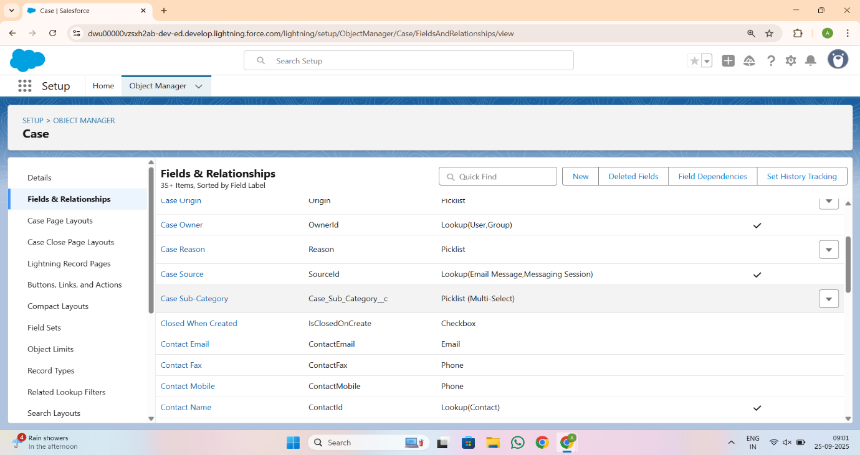Record Types were considered as a future enhancement but were not implemented in this phase, as the Case Sub-Category field met the immediate need for differentiating case types.

